Course Code | ITCD 103 | Section | 29104
Course Details | Software Development for Enterprise Systems | Date | 03/21/26
Names | Fernandez, Aaron Clifford  Gardoce, Allan Mark  Portes, John Dale  Salazar, Kaede  Sotelo, Andria Faye  Vegerano, Miguel Joseph | Hands-On Laboratory

SDLC Phase 1
Hands-on Laboratory Exercise 1

Objective: This laboratory exercise aims to help you develop a comprehensive plan for your project, covering all the essential aspects, from defining the scope to allocating resources. Through this exercise, you will:
- Define the precise boundaries of your project, what it will deliver, and what it won't include.
- identify the specific needs and functionalities your project must fulfill to achieve its goals.
- Establish SMART goals that are well-defined, measurable, achievable, relevant, and time-bound, providing a clear direction for your project.
- Learn how to consider any limitations or restrictions that may impact your project, such as time, budget, resources, or technology.
- Develop a realistic schedule for completing project tasks, ensuring you stay on track.
- Determine the people, equipment, materials, and any other resources needed to complete the project tasks and allocate them effectively.
- Identify potential challenges and develop plans to mitigate their impact, ensuring your project stays on course.
- Learn how to estimate the financial costs associated with the project and create a budget to manage your resources effectively.

1.1 Conduct Feasibility Studies
Project Title: Computer Repair Shop Management System using Salesforce
Scenario: Development of a cloud-based CRM and ticketing platform to manage customer hardware repairs, status tracking, and service history.
I. Researching Existing Solutions
- The project assessment resulted from the market solution comparison which analyzed existing market solutions. Local shops still depend on Manual Paper-Based Logs which provide initial cost savings but their design leads to frequent human mistakes and equipment damage and they lack multiple data backup systems. Standard Spreadsheets Excel and Google Sheets provide users with a digital solution but these tools do not operate automated workflows which prevents them from sending users current updates and connecting repair tickets with detailed customer information. The Dedicated Repair Shop Software from RepairShopr provides comprehensive features but its monthly subscription costs remain too expensive for small local businesses. The Proposed Salesforce Solution uses the Developer Edition which delivers professional database capabilities and automatic "Email-to-Case" functionality without any development licensing expenses.
II. Potential Technical Challenges
- The system development and implementation process needs to overcome multiple technical obstacles which must be resolved. The system operates as a cloud-native platform which needs continuous Internet access so shop staff members can access and update records in real time. The Object Mapping process needs CRM architectural knowledge to enable proper Salesforce configuration of "Standard Objects" which requires mapping "Accounts" to customers and "Cases" to repair tickets. The Data Migration process presents difficulties because shops with Excel-based legacy records need precise execution to import data into Salesforce without creating duplicate entries or mapping mistakes.

III. Resource Requirements
The following resources are estimated to be essential for the completion of the project tasks:
- Time: A period of 3 to 4 weeks is allocated for the initial configuration, iterative testing, and final documentation.
- Materials: Requirements include a Salesforce Developer Org (obtained for free), a modern web browser, and stable high-speed internet access.
- Expertise: The project team must possess fundamental knowledge of Cloud Computing, database relationships (specifically one-to-many), and Salesforce administrative tools.
IV. Ethical and Environmental Implications
- The project is designed with a strong focus on Data Privacy, ensuring full compliance with the Data Privacy Act of 2012. The system includes technical safeguards which protect sensitive customer information through encryption that only authorized technicians can access. The system supports sustainability because it digitizes the complete repair process according to Environmental Perspective. The shift to digital operations​ eliminates all physical receipts and logs and invoices, which decreases paper usage​ and creates a sustainable​ business model that operates without paper.
V. Findings and Recommendations (Deliverable)
- Based on this feasibility study, the project is highly recommended for development. The use of Salesforce provides a scalable, professional, and secure environment that is well within the technical capabilities of 3rd-year IT students. It offers a low-cost, high-impact solution for local micro-enterprises.

1.2 Define Project Objectives and Requirements
- Scenario:
Building on the chosen project idea or using a new one, each group refines the project concept.
- Task:
Each group collaboratively defines:
  - SMART goals (Specific, Measurable, Achievable, Relevant, Time-bound) for the project.
  - Functional and non-functional requirements for the project deliverable.
  - User needs and target audience.
- Deliverable:
A documented list of project objectives, requirements, and user stories.
I. SMART Goals
The project establishes the following SMART goals to ensure clear direction and measurable success:
GOAL 1: System Development
Specific: Develop a fully functional Computer Repair Shop Management System using Salesforce that manages customer records, repair tickets, status tracking, and service history.
Measurable: System must successfully process at least 50 test repair tickets with 100% data accuracy and zero critical bugs.
Achievable: Utilize Salesforce Developer Edition (free) with team expertise in cloud computing and database relationships developed through coursework.
Relevant: Addresses the real business need of local repair shops currently using inefficient manual or spreadsheet-based systems.
Time-bound: Complete initial development and testing within 3-4 weeks.

GOAL 2: User Adoption
Specific: Create an intuitive system interface that repair shop staff can use without extensive technical training.
Measurable: Achieve 80% user satisfaction rating and enable staff to complete common tasks (creating repair tickets, updating status, searching customer history) in under 2 minutes.
Achievable: Design interfaces based on standard Salesforce layouts familiar to users, supplemented with custom training documentation.
Relevant: System usability directly impacts adoption rates and determines whether shops will transition from current methods.
Time-bound: Conduct user testing and achieve satisfaction targets within the 3-4 week development timeline.
GOAL 3: Data Security Compliance
Specific: Implement security measures that fully comply with the Data Privacy Act of 2012 and protect sensitive customer information.
Measurable: Pass security audit checklist with 100% compliance on encryption, access controls, and data handling procedures.
Achievable: Leverage Salesforce's built-in security features including user authentication, role-based permissions, and encrypted data storage.
Relevant: Protects customer privacy and shields repair shops from legal liability related to data breaches.
Time-bound: Security implementation and validation completed by Week 3 of the development timeline.

II. Functional Requirements
The system must fulfill the following functional capabilities:
• Customer Management: Create, update, and search customer records with complete service history
• Repair Ticket Management: Generate unique ticket IDs, record device information, and track repair statuses
• Status Tracking: Provide real-time updates with automated email notifications to customers
• Service History: Maintain complete repair history accessible from customer profiles
• Reporting and Analytics: Display dashboard metrics and generate monthly performance reports
• User Authentication: Implement secure login with role-based permissions for Admin, Technician, and Reception roles
III. Non-Functional Requirements
The system must meet the following performance and quality standards:
• Performance: System response time under 3 seconds, supporting up to 5 concurrent users
• Reliability: 99% uptime during business hours with automatic Salesforce cloud backup
• Security: Data encryption, password complexity requirements, and Data Privacy Act compliance
• Usability: Intuitive interface requiring only 2-hour training for basic computer users
• Maintainability: Documented configuration with point-and-click customization capability
• Scalability: Support for multiple shop locations and growth to 10,000+ customer records

IV. User Needs and Target Audience
The system targets four primary user groups. Shop Owners need visibility into operations, financial reports, and data-driven insights for business decisions. Current manual systems provide no analytics, making it difficult to track revenue sources or customer retention. Receptionists require quick customer lookup, simple ticket creation, and immediate status updates. Paper logs make searches time-consuming and prevent systematic customer notifications. Technicians need clear views of assigned tickets, documentation space for technical findings, and quick status updates without workflow interruption. Current systems lack standardized repair documentation formats. Finally, Customers need transparency regarding repair status, timely pickup notifications, and secure data handling. The frustration from lack of updates currently requires frequent phone calls to shops.
The target audience consists of small to medium-sized local computer repair shops (1-5 employees) currently using manual or spreadsheet-based systems, located in areas with stable internet connectivity, seeking to professionalize operations without high software costs
V. User Stories
The following user stories represent specific scenarios from the perspective of end users:
US1: As a receptionist, I want to quickly search for a customer by phone number so that I can retrieve their information when they call about their repair status.

US2: As a technician, I want to update the repair status to "Awaiting Parts" and add a note explaining which parts are needed so that the customer can be informed of the delay.

US3: As a shop owner, I want to view a dashboard showing how many repairs are in progress, completed this week, and total revenue so that I can monitor business performance.

US4: As a customer, I want to receive an email notification when my laptop repair is completed so that I know when to pick it up without calling the shop.

US5: As a receptionist, I want to create a new repair ticket by entering device information and issue description so that the repair can be tracked from start to finish.
Conclusion:
This requirements definition establishes a clear foundation for the Computer Repair Shop Management System. The SMART goals provide measurable targets, functional and non-functional requirements specify system capabilities and quality standards, and user stories ensure the solution addresses real user needs. These requirements will guide subsequent development phases and serve as acceptance criteria for project completion.
1.3 Develop a Project Plan
- Scenario:
Each group has a well-defined project concept with goals and requirements.
- Task:
Each group develops a project plan that includes:
  - A breakdown of the project into smaller, manageable tasks.
  - A timeline for completing each task, creating a Gantt chart or using project management software.
  - Resource allocation (assigning tasks to team members based on skills and availability).
- Deliverable:
A detailed project plan with timelines, resource allocation, and communication strategies.
I. Work Breakdown Structure (WBS)
The project is divided into smaller, manageable tasks to ensure systematic development and efficient progress tracking.
Phase 1: Planning and System Design (Week 1)
- Define system architecture and object mapping (Accounts, Cases)
- Design data structure and relationships
- Identify workflow for repair ticket lifecycle
- Create initial user interface layout
- Finalize system requirements and planning documentation
Phase 2: Development and Configuration (Week 2–3)
- Set up Salesforce Developer Environment
- Create and configure objects and fields
- Develop Customer Management module
- Develop Repair Ticket Management system
- Implement status tracking workflow
- Configure Email-to-Case functionality
- Set up dashboards and reports
- Implement user roles and access permissions
Phase 3: Testing and Debugging (Week 4)
- Conduct unit testing for each module
- Perform integration testing of system components
- Identify and fix system bugs and errors
- Validate data accuracy and consistency
Phase 4: Deployment and Documentation (Week 4)
- Final system review and adjustments
- Prepare user documentation and guides
- Conduct system demonstration and user testing
- Finalize project for submission
II. Project Timeline (Gantt Chart Overview)
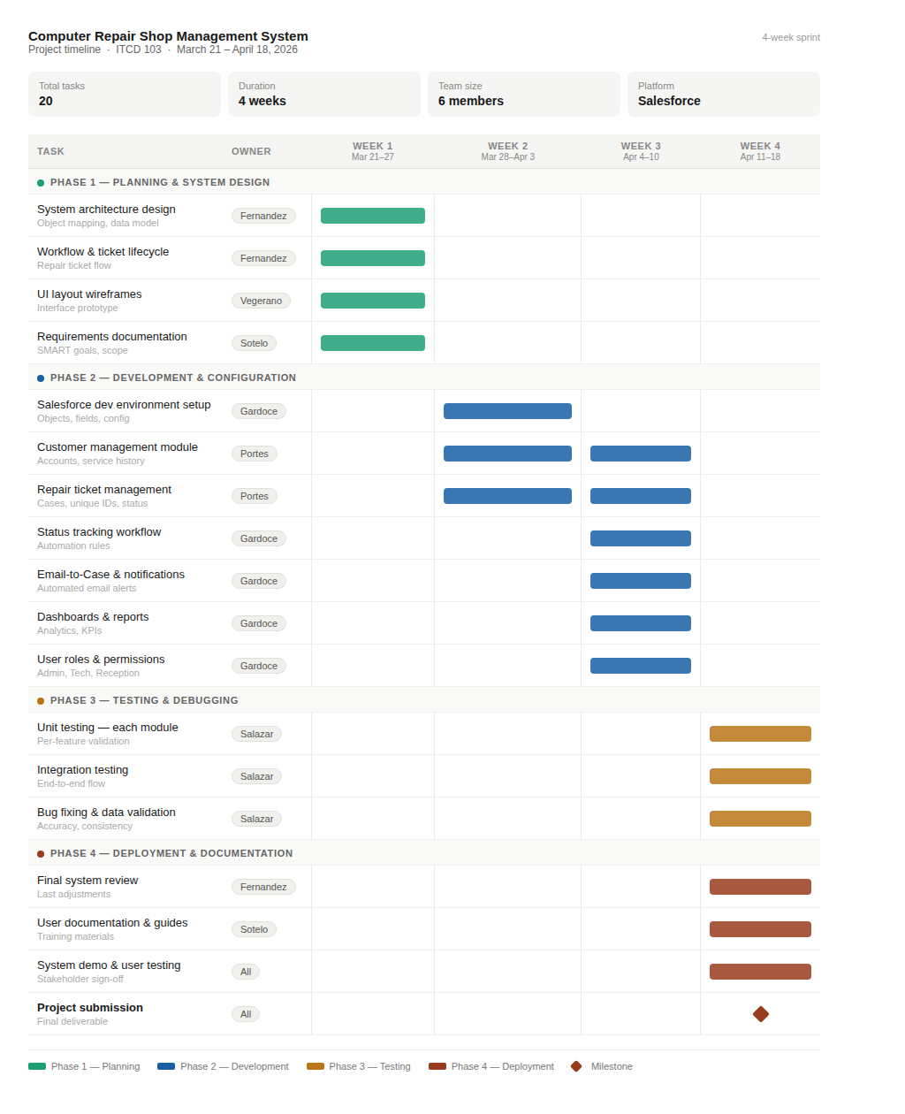
III. Resource Allocation
The project team is assigned roles based on responsibilities to ensure efficient task execution.
Team Member | Role | Responsibilities
Fernandez, Aaron Clifford | Project Manager | Oversees project progress, task distribution, and timeline
Gardoce, Allan Mark | Salesforce Administrator | Configures system, manages objects and workflows
Portes, John Dale | Developer | Implements core system features
Salazar, Kaede | QA Tester | Conducts testing and debugging
Sotelo, Andria Faye | Documentation Specialist | Prepares documentation and reports
Vegerano, Miguel Joseph | UI/UX Designer | Designs user interface and improves usability

IV. Communication Strategy
Effective communication is essential to ensure coordination and successful project execution.
- Communication Tools: Messenger, Discord, Google Meet
- Meeting Schedule: Weekly meetings (1–2 times per week) and additional meetings if needed
- Progress Monitoring: Each member reports progress weekly to the Project Manager
- File Sharing: Google Drive for centralized documentation and file management
V. Task Management Approach
The team will follow an incremental development approach:
- Tasks are divided into smaller deliverables
- Core features are prioritized before additional features
- Each module is tested before integration
- Continuous monitoring of progress to avoid delays

1.4 Identify Potential Risks and Mitigation Strategies
Risk ID | Potential Risk | Likelihood | Severity | Mitigation Strategy
R1 | Lack of knowledge in Salesforce CRM platform | High | High | Conduct training, watch tutorials, and assign team members to study Salesforce features
R2 | Internet Connectivity issues (since system is cloud-based) | Medium | High | Ensure stable internet connection and prepare offline backups of important data
R3 | Data security and privacy risks | Medium | High | Use strong passwords, enable user authentication, and follow data protection practices.
R4 | System bugs or errors during development | High | Medium | Perform regular testing and debugging use version control
R5 | Delays in project timeline | Medium | High | Create a clear schedule, assign tasks properly, and monitor progress weekly.
R6 | Miscommunication among team members | Medium | Medium | Use proper communication tools and hold regular meetings for updates
R7 | Difficulty in integrating features (ticketing, tracking, history) | Medium | High | Break tasks into smaller parts and test each feature before combining
R8 | Loss of project data | Low | High | Backup files regularly using cloud storage or external drives
R9 | User interface not user-friendly | Medium | Medium | Gather feedbacks from users and improve the design based on suggestions
R10 | Limited time for testing before submission | Medium | Medium | Allocate enough time for pilot testing in the project plan

1.5 Create a Budget and Allocate Resources
- Scenario:
Each group has a project plan and identified risks.
- Task:
Each group creates a budget for the project, estimating costs for materials, equipment, software, and any other required resources. They then determine how these resources will be allocated effectively.
- Deliverable:
A documented project budget and resource allocation plan.
Project Budget
The usage of Salesforce in the development of the Computer Repair Shop Management System requires direct and indirect resources. The estimated budget is outlined below:
Category | Item/Description | Estimated Cost (PHP)
Software | Salesforce | 0.00
 | Google Workspace/Documentation Tools | 0.00
Hardware | Laptop/PC usage (Electricity cost) | 1,200.00
Internet | Internet Subscription | 2,000.00
Training Resources | Online courses/premium tutorials | 1,000.00
Transportation | Meetings/coordination | 1,500.00
Food & Allowance | Meals during meetings/long work sessions | 2,000.00
Miscellaneous | Printing, backup storage (USB/Cloud) contingencies | 1,000.00
Total Estimated Cost |  | 8,700.00

Resource Allocation Plan
Resources are to be distributed in order to ensure efficiency and accountability throughout the project lifecycle:
- Human resources:
- Each team member is assigned roles such as Project Manager, Salesforce Administrator, Developer, Tester, and Documentation Specialist to ensure task clarity and productivity.
- Time Allocation:
- The project will be completed within 3-4 weeks, divided into:
- Week 1: Planning and system design
- Week 2-3: Development and configuration
- Week 4: Testing, revisions, and documentation
- Technical Resources:
- The team will utilize Salesforce Developer Edition, personal computers, and stable internet connections for cloud-based development.
- Communication Resources:
- Tools such as Messenger, Google Meet, or Discord will be used for coordination, weekly updates, and decision-making.
Allocation Strategy
The budget reflects a student project scenario, accounting for daily expenses such as internet, electricity, transportation, and food during collaborative sessions. Operational costs contribute significantly to the overall budget, meanwhile software costs remain minimal. The efficient allocation of resources are done by making use of free platforms in order to ensure sufficient support for productivity and collaborations.

Conclusion:
In conclusion, this laboratory exercise allowed us to create a detailed plan for the development of the Computer Repair Shop Management System using Salesforce. We learned how to define the project scope, set SMART goals, and identify the necessary functionalities to meet customer and business needs. The exercise also helped us understand how to consider constraints like time, budget, and available resources, while creating a realistic schedule for completing tasks. By planning resource allocation, estimating costs, and identifying potential challenges with mitigation strategies, we are now better prepared to execute the project successfully. Overall, this activity strengthened our ability to plan and manage a project effectively from start to finish.
Print Screen the Visual Representaion:
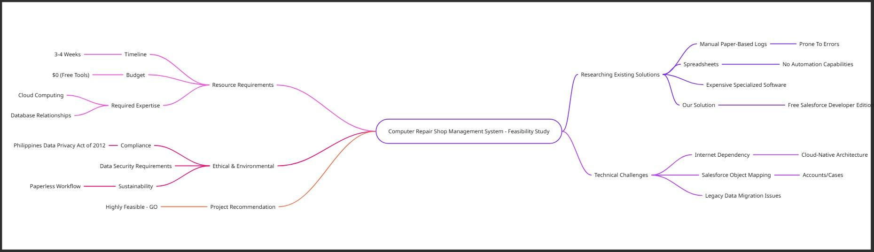
Figure 1. Mind map of the Comprehensive Feasibility Study Overview for the Proposed Computer Repair Shop Management System.

Figure 2. Gantt Chart of the Project Timeline for the Development of the Computer Repair Shop Management System

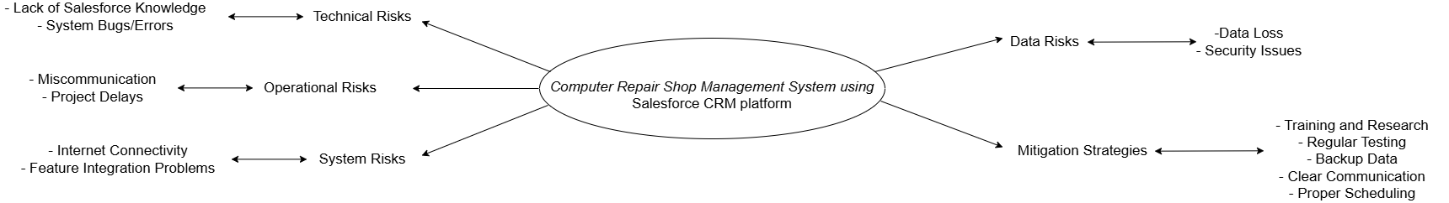
Figure 3. Mind Map of Identify Potential Risks and Mitigation Strategies

